AP Biology Lab: Phototropism in Black-eyed Pea Plants

Students will design their own experiment using shoeboxes to explore the effect of phototropism on plant growth. Bean sprouts should be planted into small cups, which should be placed in growth chambers (shoeboxes) after sprouting.

Introduction: Discuss phototropism in plants, including action of applicable hormones.

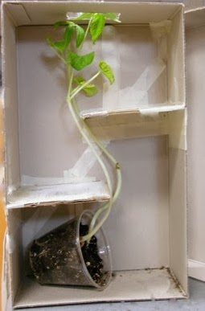
Hypothesis: How will phototropism affect the growth of bean plants when placed in specially-designed growth chambers? Be specific to your chamber design, and be sure to discuss how plant hormones would be involved in the tropic response seen.

Methodology: Students will plant bean seeds in small cups (2-3 beans per cup, in potting soil). Groups should design (and construct) various growing chambers in shoeboxes, which will test some sort of effect of phototropism on plant growth. Mrs. Dunn will maintain control plants (not in a chamber that limits the light source). Students must water and check plants daily—measure growth, make sketches in notebook, and take pictures with camera phones. Continue for approximately 2 weeks of class.
Students are responsible for designing and building their own chambers, supplying their own materials.

Data: Every day make a note of what you are seeing, which must include rough sketches in lab notebook. Photos are acceptable only for GoogleSlides only. Measure amount of plant growth (in mm) and note directionality (lateral and/or apical). Notebook should include measurements, observations, and sketches for the data section of this lab.

Analysis: Graph growth (in mm), calculate growth rate (in mm/day)- OF APICAL TIP

Conclusion: Effect of phototropism on bean plants
- Rejecting/not rejecting hypothesis
- No lab questions
- Connection to course material
- Suggested modifications to methodology or additional testing

Lab Submission (no presentations): Groups will prepare & submit a GoogleSlides deck
3 Slides: Design (chamber description), Results (growth data/analysis), Conclusion

Class GoogleSlides will be uploaded in GoogleClassroom for students to review.

